✴

**Build empathy**

The information you add here should be representative of the observations and research you've done about your users.

Empathy map

Use this framework to develop a deep, shared understanding and empathy for other people. An empathy map helps describe the aspects of a user's experience, needs and pain points, to quickly understand your users’ experience and mindset.

# Says

What have we heard them say? What can we magine them saying?

liver diseases averts the normal function of the liver

# Thinks

What are their wants, needs, hopes, and dreams? What other thoughts might influence their behavior?

evaluate the performance of different machine learning algorithms

reduce the high cost of liver

premilinary stage is important for better treatment

analyse the parameters of various classification algorithms

Give them a name and a portrait to empathize with your persona.

the doctors to diagnose within a short duration of time

sensors used for detection of infections

utilised the prediction of liver diseases

very costly

find out the best classifier for determining the liver disease

complicated

This disease is caused by an assortment of elements that harm the liver

[**Share template feedback**](https://muralco.typeform.com/to/CiqaHVat?typeform-source=app.mural.co)

# Does

What behavior have we observed? What can we imagine them doing?

# Feels

What are their fears, frustrations, and anxieties? What other feelings might

influence their behavior?

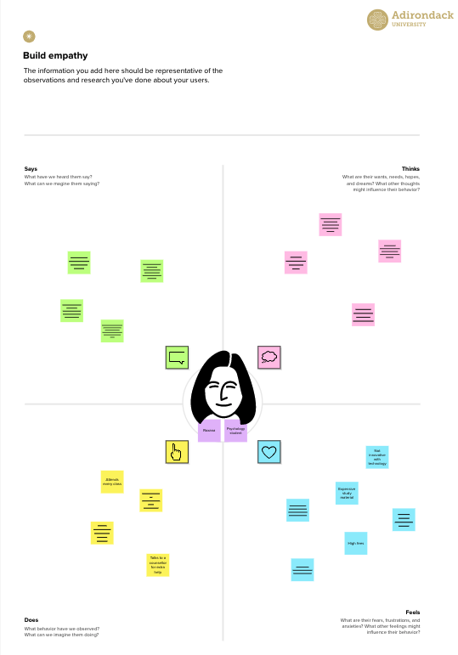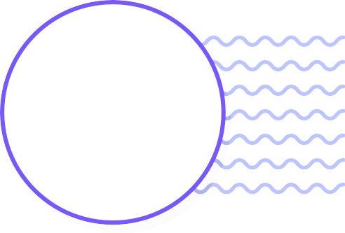

techniques are required for automatic identification of disease samples

identify the best techniques

**Template**

**Need some inspiration?**

See a finished version of this template to kickstart your work.

[**Open example**](https://app.mural.co/template/f44b7843-7c23-408c-bd36-7b0c9409dc20/96efd10c-81d2-401e-8072-4e87935e5d6b)